OOP in PHP
Prepared: TrangNTT
Lab 5. OOP in PHP 1
5.1. Open workspace and Create Folder 2
5.2. Constructor & Destructor 3
5.3. Counter – Static member 4
5.4. Object Cloning 5
5.5. Overloading 6
5.6. Abstract methods and abstract classes 8
5.7. ClassIntrospection.php 10
5.8. ObjectInstrospection.php 12
5.9. Exercise 14

Prepare
Create Lab5 directory in the lab exercise project.

Constructor & Destructor

Con_des.php
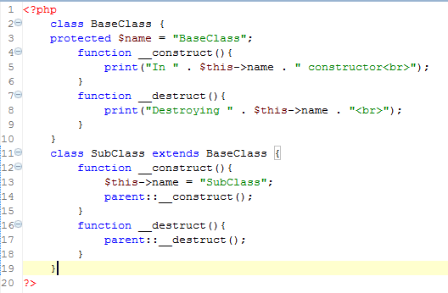

Add the following code to the end of con_des.php file:
$obj1 = new SubClass();
Run and give comments.

Add the following code to the end of con_des.php file:
$obj2 = new BaseClass();
Run and give comments.

Counter – Static member

Counter.php
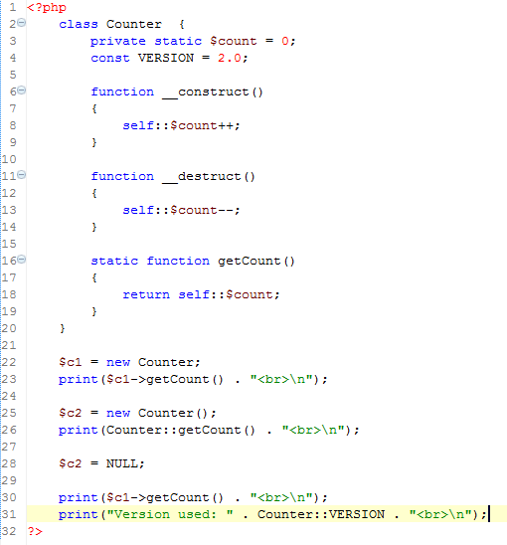

Run
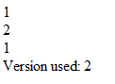

Object Cloning

ObjectCloning.php
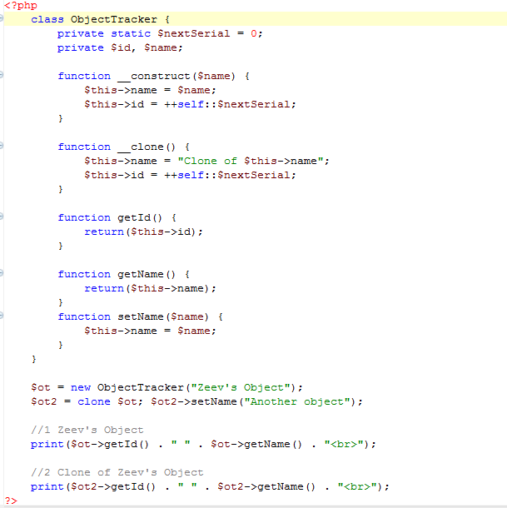

Run
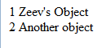

Modify ObjectCloning.php
Do not use clone but using = operator to assign ot to ot2. Observe the result and give comments.

Overloading

AttributeOverloading.php
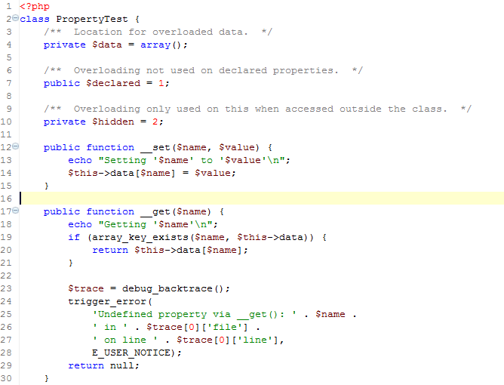
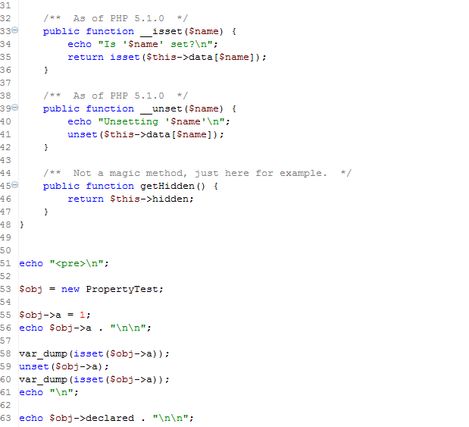
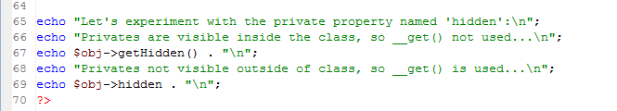

Run
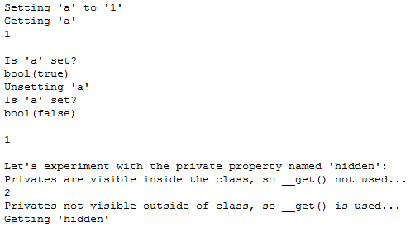

MethodOverloading.php
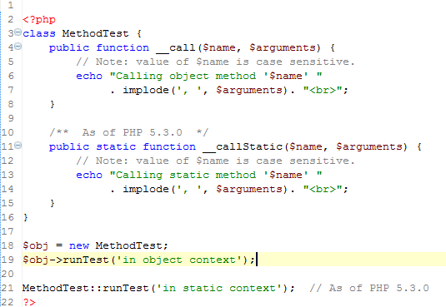

Run
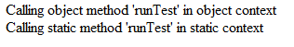

Abstract methods and abstract classes

Shape.php (New Class)
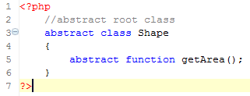

Polygon.php (New Class)
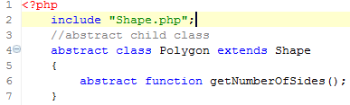

Triangle.php (New Class)
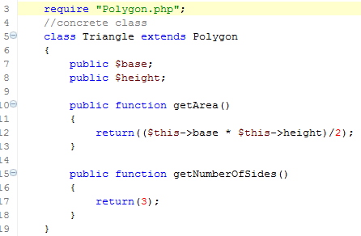

Rectangle.php (New Class)
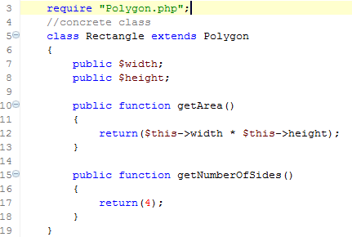

Circle.php (New Class)
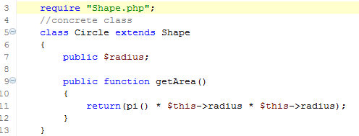

Color.php
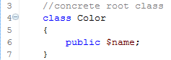

Test_Shape.php
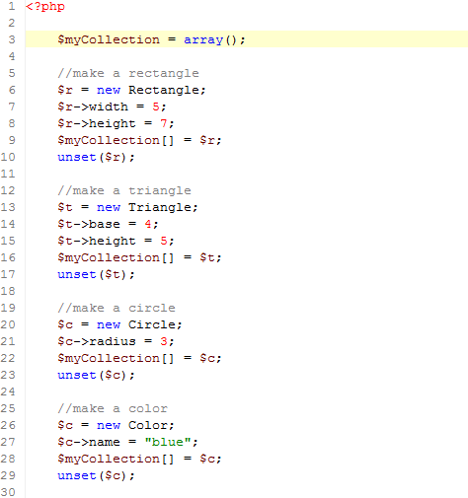
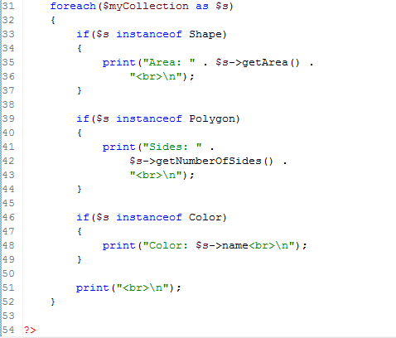

Add autoloading class scripts at the beginning of Test_Shape.php so that when runnning Test_Shape.php; it gives the following result:
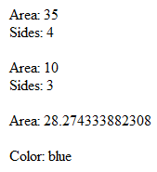

Try to use namespace for each class.

ClassIntrospection.php
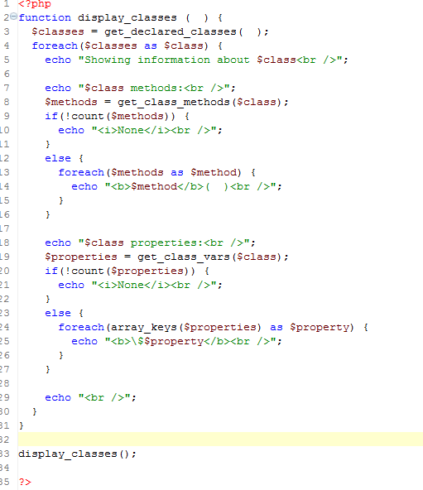
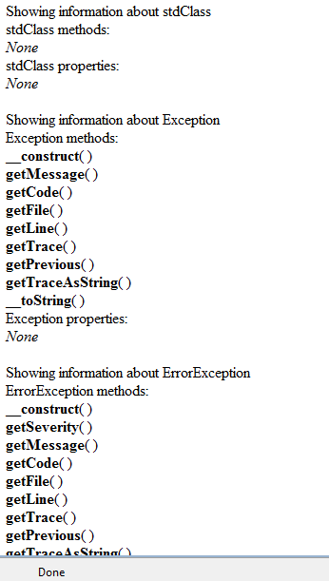

ObjectInstrospection.php
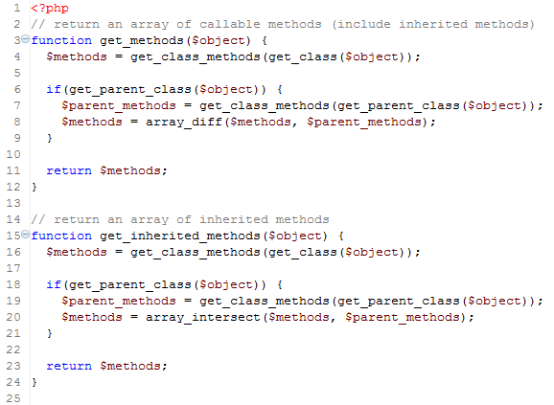
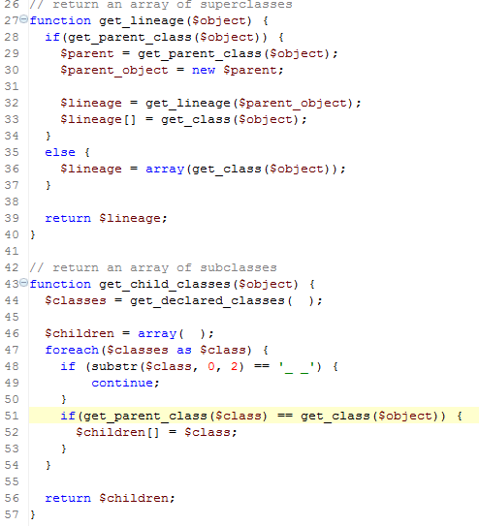
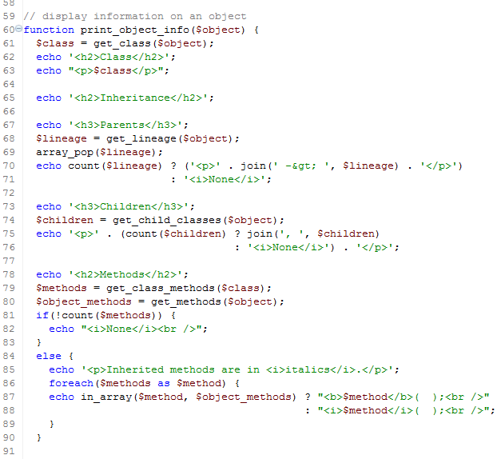
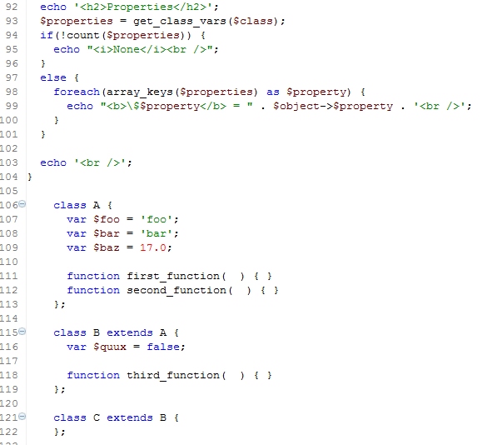
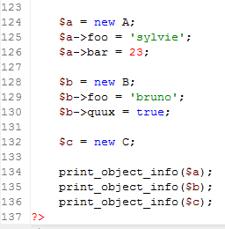
Result:
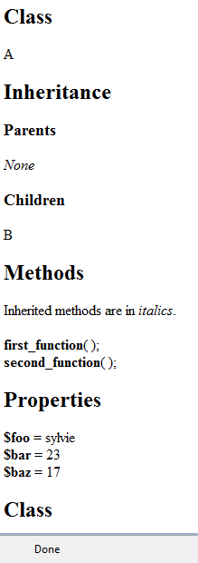

Exercise
Represented as a UML diagram, the Page class is shown in the following figure:
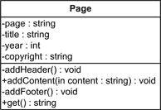
Write classes and web pages to generate several different pages and save/display them in a web browser.

